
Causal Loop Diagram (CLD)

Exercise
Full resource, see: https://www.ncrm.ac.uk/resources/online/all/?id=20845

Analyse the scenario and identify causal links and potential feedback loops, to build CLD.
The CLD is of a system which explains the causal relationship of factors that influence fish products being sold at the market to consumers.

Identify the influence of different variables in the system.

The system boundaries are limited to fish production and markets, hence disregard the connections beyond those limits. There are 17 variables in this system (provided as simplified descriptions). To complete this exercise, provide answers to the questions from (i) to (v).

Descriptions of the variables

- Capture fisheries production: Capture fisheries is the process that harvest wild fish to be supplied to markets. When the production increases, the quantities supplied to the market increases.
- Aquaculture production: Through fish farming, aquaculture supplies fish to the markets. When the production increases, the quantity supplied to the market increases.
- Demand for labour: Both capture fisheries and aquaculture are labour intensive sectors. When the demand for fish increases, more workforce is needed to enhance the production.
- Direct and indirect jobs: when the demand for labour increases, it creates room for different job opportunities. They can be varied from seagoing fisher jobs to factory-based processing jobs. In many developing countries, women play a significant role in shore-based fish handling, preserving and gear mending jobs.
- Cost of production: In both capture fisheries and aquaculture, capital costs, operational costs, utility costs, regulatory costs and miscellaneous costs are involved in fish production and harvest, therefore, it influences capture and aquaculture production practices and fish price.
- Global fuel price: Both capture fisheries and aquaculture use vessels and machinery, hence when the fuel price increases, their operational and maintenance costs increase.
- Fish price: Fish price is driven by many factors. The price is set to cover the cost of production with a profit margin. When the demand for fish is high, the price increases. But when the price is too high, the demand decreases as the consumers seek for cheaper options.
- Quantity demanded: The demand for fish is determined by fish price. If the price is affordable, more consumers buy fish and more needs to be produced.
- Distribution and value addition: Both wild caught and farmed fish products are distributed fresh, or value added, to be sold at the market.
- Supply of fish to the market: After distribution and value addition, fish products are supplied to the market.
- Quality of fish: Proper techniques improve the quality of the fish, which can be sold for a higher price. Good quality fish minimize the waste generated at markets.
- Selling fish: Market sales increases with consumer preference.
- Buying fish: Consumers buy fish at affordable prices. When consumers buy more fish, the sellers increase the fish price, seeking more profits.
- Consumer preference: Consumers purchase fish based on their preference, which can be influenced by various external factors including income and purchasing power, price of substitutes and lifestyle choices such as veganism and vegetarianism.
- Purchasing power of consumers: This is the ability of consumers to buy goods and services, which in this system, increase the consumers’ preference to buy fish.
- Per Capita Income: When the income levels increase, consumers’ purchasing power increases.
- Price of substitutes: Consumers preference to buy fish may depend on the price of substitutes such as meat. If substitutes are available for cheaper price, most consumers will preferer buying the substitute.

- The Following image shows these 17 variables placed in a random order. Using the information provided above, connect those variables using arrows. Mark the nature of the causality of each arrow with (+) or (-). Do not worry if the diagram looks a bit messy. It would usually be the case that there is a chance to re-arrange the variables. Rember, try not to connect everything with everything, just identify the key connections.
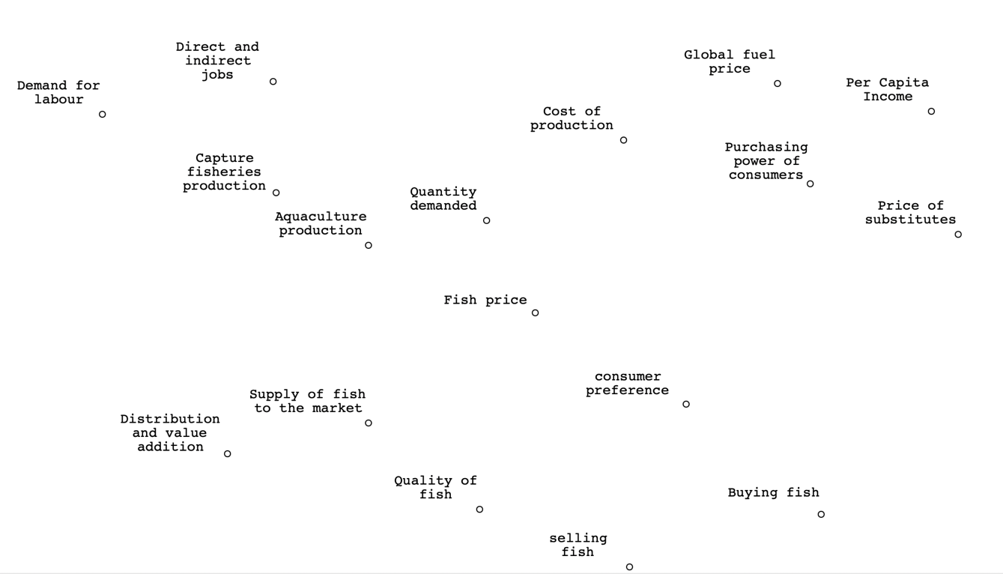

ii) Once you have completed the causal loop diagram, identify all the feedback loops present and specify whether each feedback loop is reinforcing or balancing.

iii) For each identified feedback loop, provide an explanation of how it functions. Describe the relationships between the variables in the loop and how changes in one variable affect the others over time.

iv) Choose one reinforcing loop and one balancing loop. Discuss the potential long-term impacts of each loop on the overall system. How might these loops influence status of fish price?

v) Consider a scenario where there is a sudden decrease in capture fisheries production due to a moratorium as a fishery management measure. Using the identified feedback loops, explain the potential short-term and long-term effects on the system. How might this change propagate through the loops?

* Answers to these questions are provided in a separate document. Rember: your answers may look different and still be right. This is just to give you something to compare against.

National Centre for Research Methods (NCRM)
Social Sciences
Murray Building (Bldg 58)
University of Southampton
Southampton SO17 1BJ
United Kingdom
Web www.ncrm.ac.uk
Email info@ncrm.ac.uk
Tel +44 23 8059 4539
Twitter @NCRMUK

