# Design principles for data visualisation - **Worksheet**

Full resource: <https://www.ncrm.ac.uk/resources/online/all/?id=20844>

Below are several examples of data visualisation taken from recent reports published by the UK’s Ministry of Justice. For each example, appraise whether the four principles of data visualisation have been followed. Discuss where you think the visualisation works well, and areas that you believe could be improved. The accompanying video will provide suggested solutions. Watch the video here: <https://youtu.be/P-AgHPXweSE?feature=shared>

Examples taken from the Offender Management Statistics report in 2023 (<https://www.gov.uk/government/statistics/offender-management-statistics-quarterly-october-to-december-2023/offender-management-statistics-quarterly-october-to-december-2023-and-annual-2023>)

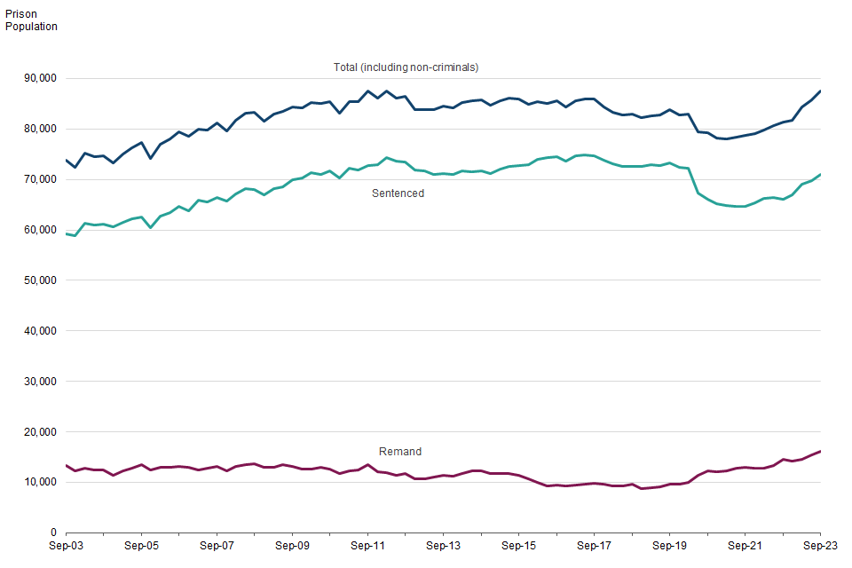  
Figure 1: Prison populations, March 2003 to 2023

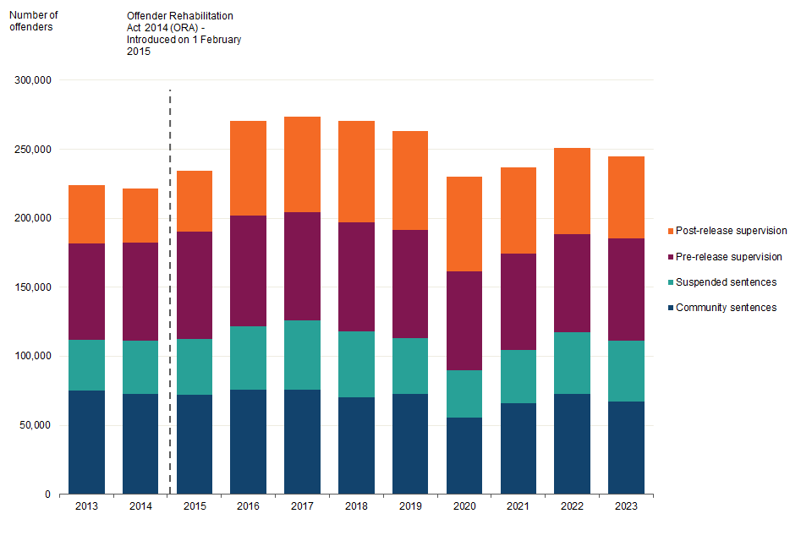

Figure 2: Number of offenders under Probation Service supervision, 31 December 2013 to 2023

Example taken from the Criminal court statistics quarterly: October to December 2023 (<https://www.gov.uk/government/statistics/criminal-court-statistics-quarterly-october-to-december-2023/criminal-court-statistics-quarterly-october-to-december-2023>)

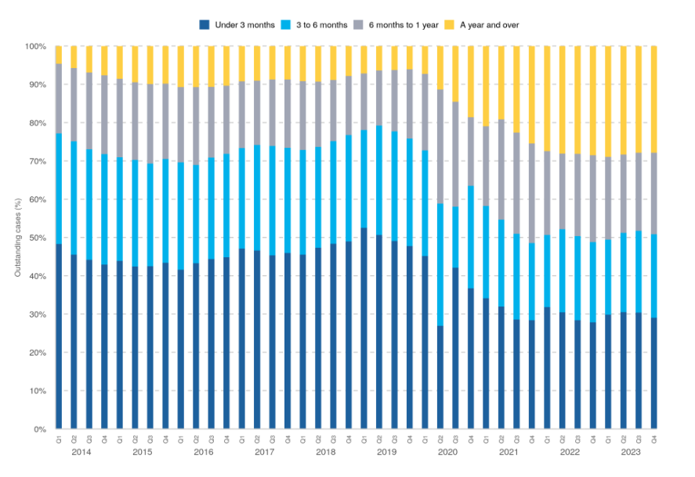  
Figure 3: Proportion of outstanding cases at the Crown Court by grouped age, Q1 2014 – Q4 2023

The following example is taken from the Justice Data Lab analysis: Reoffending behaviour after support from Only Connect (<https://assets.publishing.service.gov.uk/media/65b0de68160765000d18f774/Only_Connect_JDL_report.pdf>)

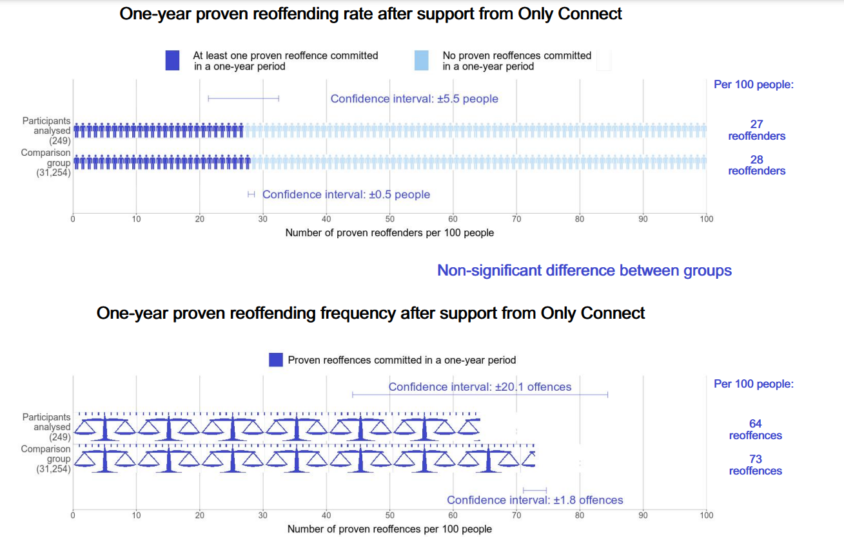

National Centre for Research Methods (NCRM)  
Social Sciences  
Murray Building (Bldg 58)  
University of Southampton  
Southampton SO17 1BJ  
United Kingdom

**Web** www.ncrm.ac.uk   
**Email** [info@ncrm.ac.uk](mailto:info@ncrm.ac.uk)  
**Tel** +44 23 8059 4539  
**Twitter** @NCRMUK